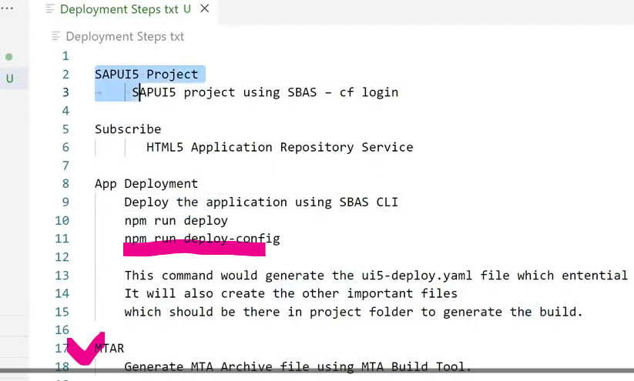

In npm run deploy-config >> we can select abap / cf
Workbench TR >> all app related info
Customizing TR >> Tiles, groups and catalogs

Pallate parameter in TD use to modulerize desiging by creating variables
Lighten (_) >> function in TD
